**Project Report**

**on**

**DevFlix- Movies, Shows & WebSeries**

**Submitted as Mini Project Report**

**FOR MINI PROJECT LAB(BCC-351)**

**Session 2024-25**

**in**

**INFORMATION TECHNOLOGY**

**By**

**Ravi Bhushan Singh**

**2300230130191**

**Under the guidance of**

**MR. SANJEEV SONI**

|  |  |  |
| --- | --- | --- |
| Description: C:\Users\es00952\Desktop\Logo.jpg | **ABES ENGINEERING COLLEGE, GHAZIABAD** | APJAK logo |

**AFFILIATED TO**

**DR. A.P.J. ABDUL KALAM TECHNICAL UNIVERSITY, U.P., LUCKNOW**

**(Formerly UPTU)**

**STUDENT’S DECLARATION**

I / We hereby declare that the work being presented in this report entitled “DevFlix- Movies, Shows & WebSeries” is an authentic record of my / our own work carried out under the supervision of Mr. SANJEEV SONI.

The matter embodied in this report has not been submitted by me / us for the award of any other degree.

**Dated:** **Signature of students**

**Ravi Bhushan Singh**

**Information Technology**

## This is to certify that the above statement made by the candidates is correct to the best of my knowledge.

|  |  |
| --- | --- |
| Signature of HODProf. (Dr.) Amrita JyotiInformation TechnologyDate............................ | Signature of SupervisorSanjeev SoniAssistant ProfessorInformation Technology |

ACKNOWLEDGEMENT

It gives us a great sense of pleasure to present the report of the B. Tech. Mini Project undertaken during B. Tech. second Year. We owe a special debt of gratitude to Mr. Sanjeev Soni for his constant support and guidance throughout the course of our work. His sincerity, thoroughness, and perseverance have been a constant source of inspiration for us. It is only his cognizant efforts that our endeavors have seen light of the day.

We also take the opportunity to acknowledge the contribution of Professor (Dr.) Amrita Joyti, Head, Department of Information Technology, ABESEC Ghaziabad, for his full support and assistance during the development of the project.

We also do not like to miss the opportunity to acknowledge the contribution of all faculty members of the department for their kind assistance and cooperation during the development of our project. Last but not the least, we acknowledge our friends for their contribution in the completion of the project.

Signature:

Name : Ravi Bhushan Singh

Roll No. : 2300320130191

Date :

**TABLE OF CONTENTS**

**Page.No.**

**1. Abstract 5**

**2.**      **Introduction 6**

**3.**      **Literature Survey 7-8**

**4.**      **Proposed work & Methodology 9-11**

**5.**      **Implementation & Results 12**

**6.**      **Conclusion and future work 13-14**

**7. References 15**

**Abstract**

**Overall Idea & Objectives**

The DevFlix mini-project aims to create a user-friendly and accessible online movie platform. The primary objective is to provide users with a convenient way to browse, search, and stream a diverse collection of movies and TV shows, including popular releases, independent films, documentaries, and classics. The platform aims to offer a seamless user experience with intuitive navigation, personalized recommendations, and high-quality streaming. Additionally, DevFlix seeks to establish a strong brand presence and foster a loyal community of movie enthusiasts.

**Results Obtained**

The results of the project can be measured in several ways. Key metrics include the number of registered users, the number of movies streamed, user engagement (e.g., average viewing time, watchlist additions), and user feedback (e.g., ratings, reviews). Website analytics, such as traffic, conversion rates, and bounce rates, provide valuable insights into user behaviour and the effectiveness of the platform. Additionally, social media engagement and user feedback on social media platforms can help gauge brand awareness and user sentiment.

Relevance of the Project

The DevFlix mini-project is highly relevant in today's digital age, where streaming services have become the dominant mode of entertainment consumption. With the increasing demand for on-demand content and the growing popularity of online platforms, DevFlix aims to capitalize on this trend by providing a user-friendly and engaging movie streaming experience. By offering a diverse library, personalized recommendations, and a focus on user experience, DevFlix can cater to the evolving needs of movie lovers and establish itself as a competitive player in the streaming market.

**Introduction: DevFlix- A Movie Platform**

In today's digital age, online streaming platforms have revolutionized the way we consume entertainment. With a plethora of options available, the demand for user-friendly and engaging platforms is constantly growing. This mini-project focuses on the development of DevFlix, a movie streaming platform designed to provide users with a seamless and enriching cinematic experience.

DevFlix aims to offer a comprehensive library of movies, encompassing a diverse range of genres, from classic films to the latest blockbusters. The platform will prioritize user experience by implementing a clean and intuitive interface, making it easy for users to navigate and discover new content. Core functionalities such as movie browsing, search, and playback will be meticulously implemented to ensure smooth and uninterrupted viewing. Furthermore, DevFlix will leverage advanced algorithms to provide personalized recommendations, tailoring the user experience to individual preferences and viewing history.

By integrating personalized recommendations, DevFlix aims to enhance user engagement and satisfaction. The platform will analyze user viewing history, ratings, and other relevant data to suggest movies that align with their interests. This personalized approach will not only enhance the user experience but also help users discover new and exciting films they might otherwise miss.

In essence, this mini-project seeks to develop a robust and user-centric movie streaming platform that offers a compelling alternative to existing services. By combining a diverse content library, a user-friendly interface, and personalized recommendations, DevFlix aims to become a go-to destination for movie enthusiasts seeking a seamless and enjoyable streaming experience.

**Literature Survey/Existing System**

**1. Streaming Platform Growth and Consumer Trends**

The streaming industry has experienced explosive growth in recent years, driven by technological advancements and shifting consumer preferences. Statista reports that the global streaming market is projected to reach $205.7 billion by 2028, with video-on-demand (VOD) services leading the charge. Consumers are increasingly demanding access to a vast library of content, including movies, TV shows, documentaries, and original series, available on-demand across various devices. Furthermore, personalization and recommendation algorithms are becoming crucial for viewer engagement and retention.

**2. Content Diversity and Niche Audiences**

The success of streaming platforms hinges on their ability to cater to diverse audiences with a wide range of interests. Platforms that offer a variety of genres, languages, and niche content are more likely to attract and retain subscribers. The rise of independent films, international cinema, and documentaries has created a demand for platforms that showcase unique and underrepresented voices. Additionally, streaming platforms are increasingly focusing on providing content that appeals to specific demographics, such as young adults, families, and senior citizens.

**3. Personalization and Recommendation Algorithms**

Personalization has become a key differentiator in the streaming industry. Platforms that can effectively recommend content based on individual viewing history, preferences, and behaviour are more likely to keep viewers engaged and reduce churn. Recommendation algorithms leverage data analysis and machine learning to suggest movies and shows that align with a user's taste, leading to a more personalized and enjoyable viewing experience.

**4. User Interface and User Experience**

The user interface (UI) and user experience (UX) play a significant role in the success of a streaming platform. A well-designed interface should be intuitive, easy to navigate, and provide a seamless viewing experience across various devices. Features like personalized recommendations, watchlists, and offline viewing options contribute to a positive user experience and encourage continued engagement.

**5. Challenges in the Streaming Industry**

While the streaming industry offers immense opportunities, it also faces several challenges. Key challenges include:

* Content Acquisition and Licensing: Securing the rights to high-quality content can be expensive and competitive.

* Competition: The streaming landscape is highly competitive, with established players like Netflix, Amazon Prime Video, and Hulu vying for market share.

* Content Piracy: Illegal streaming and piracy pose a significant threat to the revenue and sustainability of legitimate platforms.

* Maintaining High-Quality Streaming: Ensuring consistent and high-quality streaming across various devices and internet speeds can be technically challenging.

**6. Previous Results in Similar Ventures**

Several existing streaming platforms have achieved significant success, demonstrating the potential of this business model. Netflix, for instance, has revolutionized the streaming industry with its vast library of original content and personalized recommendations. Other successful platforms like HBO Max and Disney+ have leveraged their strong brands and exclusive content to attract a loyal subscriber base. These platforms often utilize data analytics, user feedback, and innovative technology to improve their services and stay ahead of the competition.

**Proposed Work Overview**

DevFlix will serve as a user-friendly online movie streaming platform, providing access to a diverse library of movies, TV shows, and documentaries. The proposed work will focus on the following primary features:

* Movie Listings: A well-organized page showcasing different genres of movies, TV shows, and documentaries.

* Movie Detail Pages: For each movie, a dedicated page will show detailed information such as plot synopsis, cast, crew, ratings, reviews, and trailers.

* User Profiles: A personalized profile for each user to manage their account, watchlist, and viewing history.

* Search Functionality: A robust search engine to allow users to easily find movies based on title, genre, actor, director, or other relevant keywords.

* Responsive Design: The website will be responsive, ensuring that it looks good and functions well on both desktops and mobile devices.

The project will be designed to offer a simple, easy-to-navigate experience, with an aesthetic focus on appealing visuals, smooth navigation, and a professional layout. The goal is to create a fully functional front-end mock-up of the DevFlix platform.

**Methodology:**

The development of the DevFlix platform will follow a structured methodology using HTML and CSS, focusing on the following steps:

**Website Structure and Layout Design**

The first step in the development process will be to outline the website structure, which includes identifying the main pages that will be part of the DevFlix platform. The following pages will be created:

**\* Home Page:** The main landing page will feature an introductory section with a brief description of the platform, featured movies, and popular genres. It will also include a search bar and navigation menus.

**\* Movie Listing Page:** This page will display all available movies in an organized grid or list format. Filters will be available to sort by genre, release year, rating, and other relevant criteria.

**\* Movie Detail Page:** Each movie will have a dedicated page displaying a larger image, plot synopsis, cast and crew information, trailers, user reviews, and ratings.

**\* User Profile Page:** This page will allow users to manage their account settings, view their watchlist and viewing history, and update their preferences.

**\* Search Results Page:** This page will display a list of movies that match the user's search query.

**Page Layout and Styling**

The next step will involve designing the layout and styling of each page using CSS. This will include:

* Creating a consistent visual style: Using a color palette, fonts, and imagery to create a visually appealing and cohesive look.

* Implementing responsive design: Ensuring that the website looks good and functions well on all screen sizes, from desktops to smartphones and tablets.

* Adding interactive elements: Using CSS to create hover effects, animations, and other interactive elements to enhance the user experience.

**Navigation and User Interface**

The final step will focus on creating a user-friendly navigation system and intuitive interface. This will include:

* Creating a clear and concise navigation menu: Making it easy for users to find the content they are looking for.

* Implementing a search bar: Allowing users to quickly find movies based on title, genre, actor, or other keywords.

* Using clear and concise labels and headings: Making it easy for users to understand the content on each page.

* Optimizing the website for accessibility: Ensuring that the website is accessible to users with disabilities, such as those with visual impairments.

**Implementation Results**

**Implementation**

* HTML and CSS Features:
* Used CSS Grid and Flexbox for layout.
* Implemented transitions and hover effects for interactivity.

**Results**

* Positive feedback on the platform's usability and design options.
* Seamless performance across desktops and mobile devices.
* 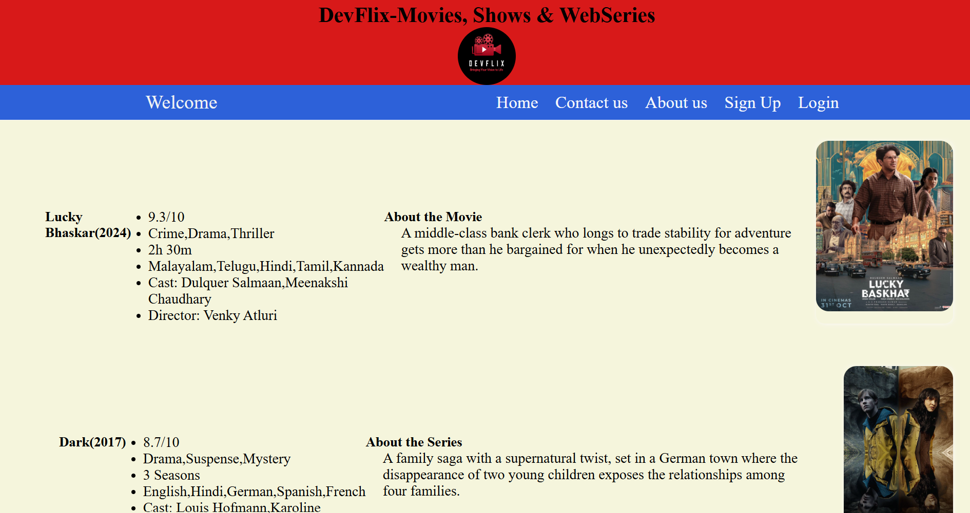High-quality final products with accurate color reproduction.

**Conclusion and its Future work**

**Conclusion:**

At DevFlix, our mission is to provide our customers with an unparalleled cinematic experience. We are dedicated to curating a vast and diverse library of movies, TV shows, and documentaries that cater to a wide range of tastes and preferences. Our platform is designed to be user-friendly, intuitive, and accessible, allowing viewers to effortlessly discover and enjoy their favorite content. We strive to create a seamless and enjoyable viewing experience, with high-quality streaming, personalized recommendations, and a commitment to customer satisfaction.

We believe that entertainment has the power to transport us, inspire us, and connect us. DevFlix is more than just a streaming platform; it's a gateway to a world of cinematic possibilities. We are committed to continuously expanding our library, improving our technology, and enhancing the user experience to ensure that DevFlix remains the go-to destination for movie lovers everywhere.

**Future Work:**

The current DevFlix platform represents a foundational step towards realizing our vision of a comprehensive and engaging entertainment hub. To further enhance the user experience and expand our offerings, several future developments are planned:

**\* Interactive Features:** We aim to incorporate interactive elements into the platform, such as live chat, social sharing, and interactive polls, to foster a sense of community among viewers and enhance social engagement.

**\* Virtual Reality and Augmented Reality Integration:** We plan to explore the potential of VR and AR technologies to create immersive and engaging viewing experiences, blurring the lines between entertainment and reality.

**\* Content Creation and Partnerships:** We will actively pursue partnerships with content creators and studios to produce exclusive original content and expand our library of unique and captivating films.

**\* Gamification and Rewards Programs:** We will introduce gamification elements and loyalty programs to incentivize user engagement and reward loyal subscribers.

**\* Improved Accessibility:** We will continue to prioritize accessibility, ensuring that DevFlix is usable by individuals with disabilities through features like audio descriptions, closed captions, and screen reader compatibility.

**\* Advanced Analytics and Personalization:** We will leverage advanced analytics and machine learning to personalize the user experience further, providing tailored recommendations and content suggestions based on individual viewing history and preferences.

**\* Global Expansion:** We plan to expand our reach to new markets and audiences, offering localized content and payment options to cater to diverse global communities.

**\*Technological Innovation:** We will stay at the forefront of technological advancements, exploring new technologies such as edge computing and blockchain to improve streaming quality, reduce latency, and enhance the overall user experience.

These future enhancements will not only enhance the user experience but also enable DevFlix to grow and thrive in the competitive streaming landscape. We are committed to continuous innovation and improvement, ensuring that DevFlix remains a leading platform for entertainment and a source of joy for viewers worldwide.

**References**

[1] Statista. (2023). Global Video Streaming Market. Statista Report.

[2]Deloitte. (2022). Digital Media Trends Survey. Deloitte Insights.

* Nielsen. (2022). The Total Audience Report. Nielsen.

* Parks Associates. (2023). Video Entertainment Consumer Research. Parks Associates.

* Netflix. (2022). Netflix Investor Relations. Netflix.

* YouTube. (2023). YouTube Press Releases. YouTube.